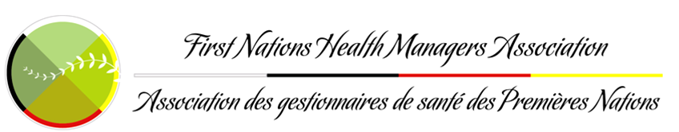
2022-2023 MEMBERSHIP APPLICATION
Name: |  |  |  | □Mr. □Ms. □Mrs. □Dr. Designations:
Home Address: | City: |  |  |  | Province: |  |  |  | Postal Code:
Home Phone:  ( ) | Mobile:  ( ) |  |  |  |  | Home Email:
Organization Name: |  |  |  | Position:
Organization Address: | City: |  |  |  | Province: |  |  |  | Postal Code:
Work Phone:  ( ) | Work Fax:  ( ) |  |  |  |  | Work Email:
FNHMA Membership Directory:
Joining FNHMA’s Membership Directory allows you to network and share best practices with fellow First Nations Health Managers from across the country. Would you like your primary address listed in our online members only Membership Directory?*
YES NO
* Please note that if neither option is chosen the default option will be to have your information included.
Type of Membership:  □ Candidate Member  □ Corporate - Individual Associate Member  For other Corporate categories of membership contact the Chief Executive Officer |  |  |  |  |  |  |  | Membership Fee:  □ $175.00  □ $175.00
Total Membership Fee with taxes included:
Tax is based on your province of residence. Please select one :
□ QC, AB, SK, MB, BC, NWT, NV, YK (5% GST added) $183.75  □ ON, NB, NFLD, (with 13% HST added) $197.75  □ GST/HST exempt (no tax added) $175.00 |  |  | □ PEI, (with 14% HST added) $199.50  □ NS, (with 15% HST added) $201.25
Please include proof of tax exemption at time of application (A letter of exemption from your employer and/or a copy of your status card – you must have an on-reserve mailing address)
□ I have enclosed a cheque payable to “FNHMA“ □ Visa □ MasterCard
Card Number: |  | Expiry Date:  / |  |  |  |  | Signature:
Name on Card: |  |  |  |  |  |  | Amount Paid:

